Project Design Phase
Solution Architecture

Date | 13 October 2026
Team ID
Project Name | Vehicle Insurance Management
Maximum Marks | 4 Marks

Solution Architecture:
Solution architecture is a complex process – with many sub-processes – that bridges the gap between business problems and technology solutions. Its goals are to:
- Find the best tech solution to solve existing business problems.
- Describe the structure, characteristics, behavior, and other aspects of the software to project stakeholders.
- Define features, development phases, and solution requirements.
- Provide specifications according to which the solution is defined, managed, and delivered.
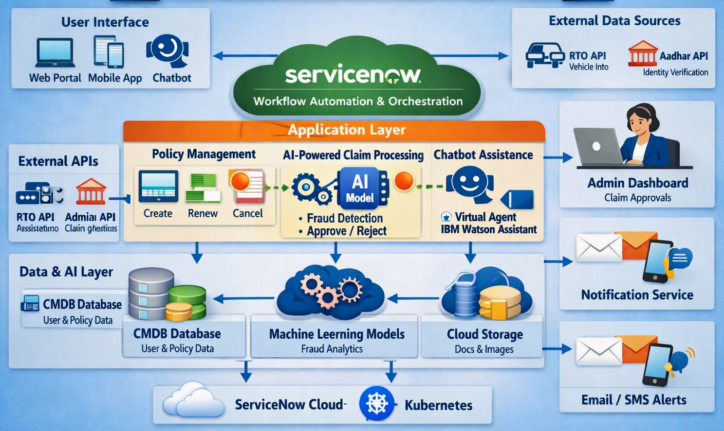
Architecture Layers
- User Interface: Web portal, mobile app, chatbot for customer and agent interaction.
- ServiceNow Platform: Workflow automation, orchestration, and integration hub.
- Application Layer:
  - Policy Management (create, renew, cancel)
  - AI-powered Claim Processing (validate, fraud detection, approve/reject)
  - Chatbot Assistance (Virtual Agent + IBM Watson)
- Data & AI Layer:
  - CMDB Database (customer & policy data)
  - Cloud Storage (documents & images)
  - ML Models (fraud analytics, claim prediction)
- External APIs: RTO API (vehicle info), Aadhar API (identity verification).
- Admin & Notifications: Admin dashboard for approvals, notification service for email/SMS alerts.
- Infrastructure: ServiceNow Cloud + Kubernetes for scalability and resilience.

